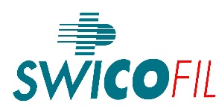 |  |  | PASSION FOR SUCCESS
Swicofil AG
CH-6021 Emmenbrücke

Tel.: | +41 41 2673464 | attn.: Swicofil AG
E-Mail: | team1@swicofil.com | cc.: ……….
Date: | Januar 14, 2016
 |  | inquiry date:

Plasma Coating Inquiry |  | Swicofil
 |  | .......

- Information on the substrate:  YARN material/polymer (PET?) :  state of material: (FDY/h.t.?)  brightness/cross-section  count in dtex:  no. of filaments:  twist of feeder yarn  color: rawwhite  merge:  treatment before coating? | - Customer info:  customer name:  project name:  address  country  contact person  telephone:  email address:  end use system:  first machine to go on:  final application:  description of function:
- requested properties of coating:  Coating metal:  desired resistivity Ohm/cm:  metal content in mg/m  oiling needed (%): | - put up / bobbin / requested quantity:  Put up / bobbin bobbin type: ZH 57/175 rounded top, black  desired quantity:  meters per bobbin  no. of bobbins:  desired packing:  :
- steps after coating:  after coating twisting after coating: ……… tpm …. direction  other finishing operations  desired delivery time: | - commercial infomation:  Kommerziell your price idea  Incoterms:  potential per year:
- comments / additional information:

E-Mail to team1@swicofil.com

