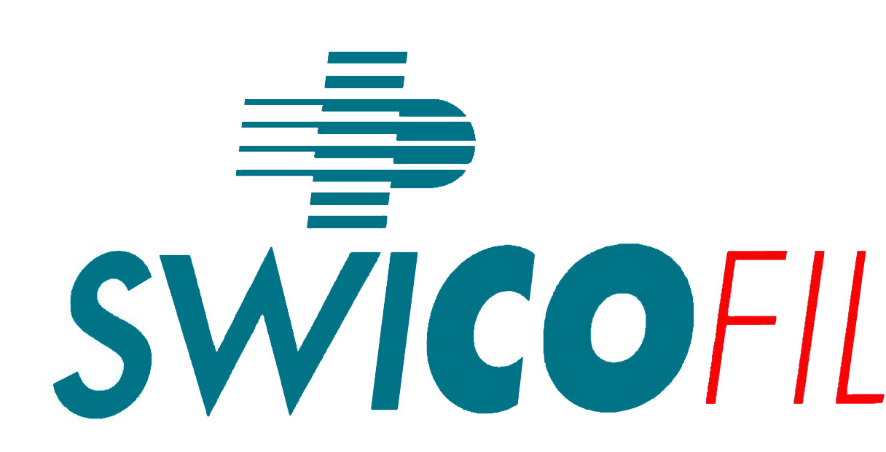 |  | PASSION FOR SUCCESS | Inquiry CHECKLIST  To help YOU providing all details. We love to serve YOU WELL – kindly return it with all green fields completed
Swicofil AG
CH-6021 Emmenbrücke

From agent: |  | Country:
Company name: |  | Client tel. off.
Y/Address: |  | Client tel.mob
 |  | Client Email:
 |  | Contact pers.

 | Descriptor | Please fill in |  | your choices
1. Which product? |  |  | ⇓ |  |  |  |  |  |  |  |  = MUST entries   = if you know entries
 | Material |  |  | PA 6.6 | PA … |  | PET | PP |  | PE |  | CO |  | WO | Li |  | CV | other (which?)
 | Type |  |  | textile filam.  - flat  - POY  - text. Set  - text. HE  - Stretch  - KdK  - airtext. |  | h. tenacity  Pls. quote:  - tenacity  - shrinkg.  - elongat. |  |  | Flock  Pls. quote:  - cutflock  - ground |  |  |  | monofilamt.  Pls. quote:  - diametr  - tenacity  - shrinkg.  - elongat. |  |  | Spun yarns |  | Fibers  Pls. quote:  - cut-length  - tops?
 | Brightness |  |  | semidull |  | bright |  |  | dull |  |  |  | superbright |  |  |  |  | other (which?)
 | Cross-section |  |  | round |  | trilobal |  |  | octalobal |  |  |  | multilobal |  |  | special |  | other (which?)
 | Count details |  |  | Pls. quote: |  | dtex, filaments, ply, twist direction and no. of turns / m, cutlength
 | Colour |  |  | Pls. quote: |  | rawwhite |  |  | yarndyed |  |  |  | spundyed |  |  | col. No.
 | Requ. put up |  |  | Pls. quote which: |  | cylinders + max.outer ∅ |  |  | cops |  |  |  | cones |  |  | TKB |  | TKB/WKB

2. Quantity information
 | Trial quantity |  | Pls. quote quantity for first trial order (and no. of bobbins needed) + desired del.date
 | 1st com.delivery |  | Pls. quote quantity of first intended order if trial is ok
 | Potential/year |  | Pls. quote what the potential is which you are looking at

3. Usage of the yarn This section is very important to serve you with the right product
 | End use system: |  | hosiery  - plain  - plating  - laid in | texturizing  - pin  - friction  - air  - KdK | weaving  Pls. quote:  - warp  - sized  - unsizd  - weft  - system | knitting  Pls. quote:  - circular  - warpkn.  - rachel  - flat knit | twisting or covering | twining or braiding
 | End use system: |  | flocking  - fabrics  - automot  - gadgets  - yarn  Pls quote which elect. system AC or DC | spinning  - cotton  - ring  - O.End  - airjet  - wool  -worst’d  - carded  - linen | non woven  - needle  - wadding  - blowing  - water  - bonding
 | Name of first machine |  | Pls. quote: | Producer | modell | speed | gauge | width
 | Final application |  | What is the product finally used as? Please be very specific.

4. Economic background details
 | Competitor |  | Who is/was your supplier so far?
 | Comp. price |  | Pls. quote: | price | Incoterms | payment
 | Remarks

Swicofil will not be able to offer to inquiries where information marked with  is not provided!
By email to: Swicofil AG / attn. .. team1@swicofil.com

